Setting Up the First ESDS User

(A Quick Guide for Administrators)

Follow the procedure below to set up the first user for a tenant.
At the end of this process, the following items will be set up:
- First user is established.
- Tenant name is configured. Note that the Tenant is not created until the Landing Zone is setup. The Tenant ties the Administrator users together.

- Select inBloom from the Realm Selector.
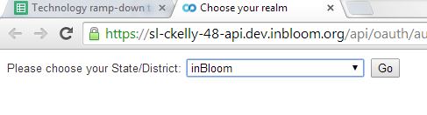
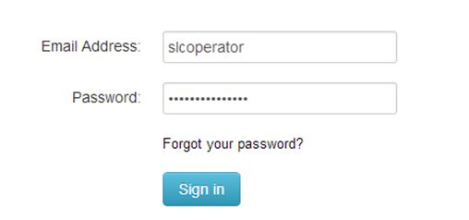
- Log in with slcoperator and enter the provided Password.

- Once logged in, click Admin in the top right corner.

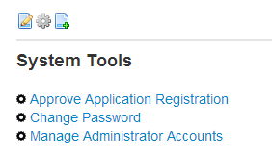
- Select Manage Administrator Accounts from the System Tools.

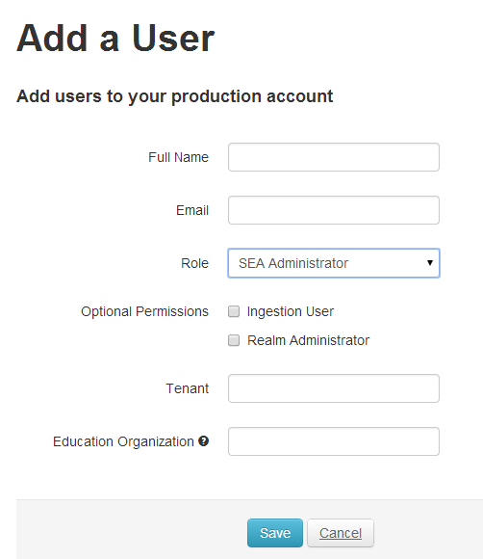
- Click Add User at the bottom of the Manage Administrator Accounts screen.

- Enter information for the user.
- Full Name
- Email – this will also be your username and must be unique across the ESDS instance.
- Role – select SEA Administrator. When creating an account for a customer, you will always choose SEA Administrator.
- Optional permissions:
  - Ingestion User – select
  - Realm Administrator – select (gives role Realm Administrator)
- Tenant – This is decided by the customer and must be unique across the ESDS instance.
- Education Organization – The Education Organization ID of the SEA referenced in your data.
- Click Save. An email will be sent to the newly created SEA Administrator with instructions on setting up a password. After a password has been created the following will occur:
  - The user is redirected to the Realm Selector. The SEA Administrator needs to log into the ESDS Realm to get started and create their Realm.
  - A Welcome email is sent with a link to log in to the system.

Copyright Notice
© 2014 Educational Secure Data Services
All rights reserved. No part of this document may be reproduced or transmitted in any form or by any means, electronic, mechanical, photocopying, recording, or otherwise, without prior written permission of ESDS.

